vSlot 20 x 40
# | Size | Length (mm) | Qty | Description | Picture
 | 20 x 40 | 550 | 4 | 10mm in and 20 x0 20 centres  Each end | 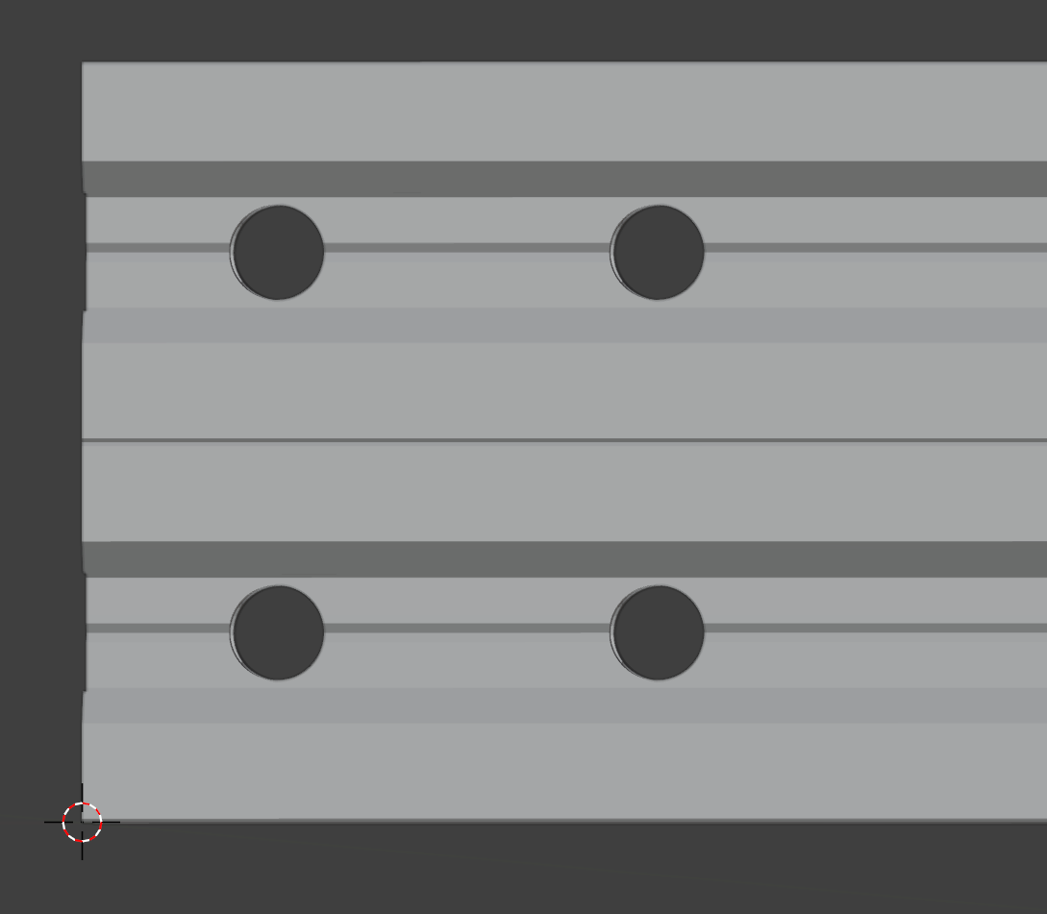
 | 20 x 40 | 550 | 4 | On the same pieces as above | 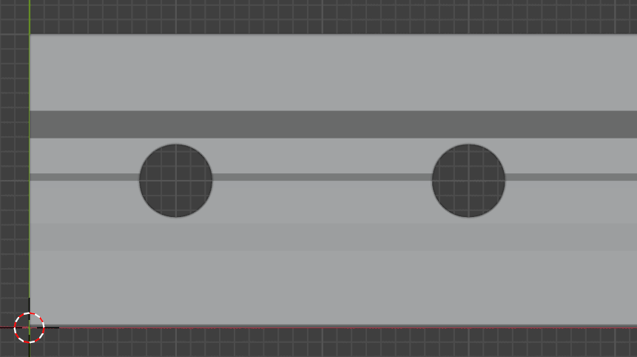
 |  |  |  | Result | 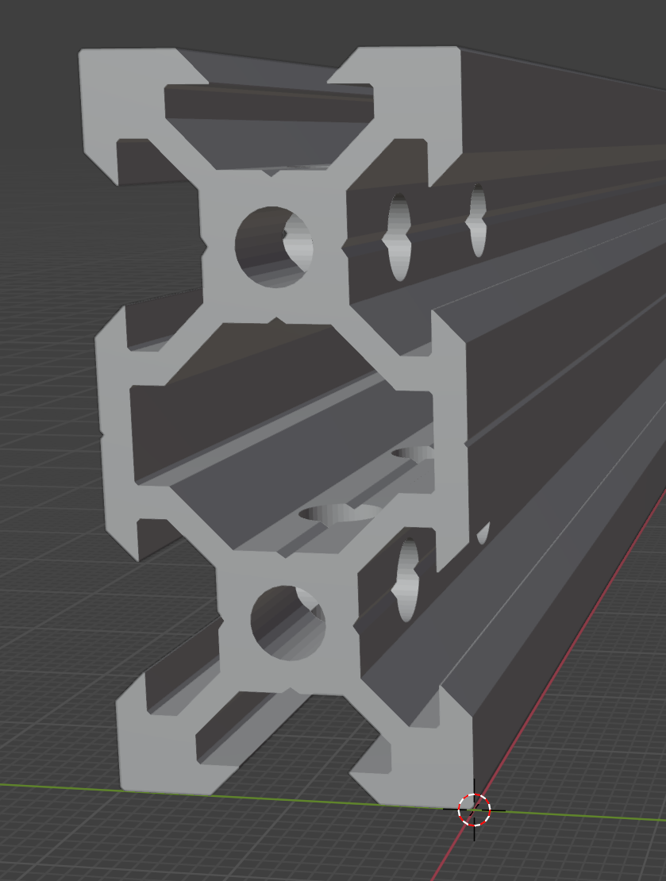
 | 20 x 40 | 500 | 4 | Two holes at exactly 410mm | 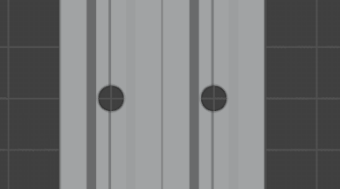
 | 20 x 40 | 500 | 4 | Same pieces as 3  One hole horizontally at exactly 410mm | 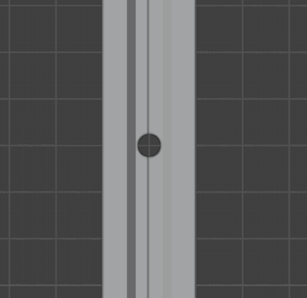
 |  |  |  | Result | 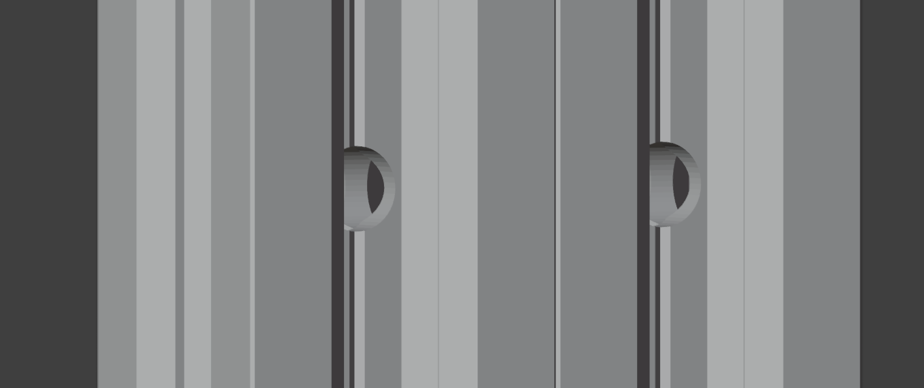
 | 20 x 40 | 460 | 2 | One vertical hole across the 40mm 400mm from one end. TO BE DETERMINED AFTER INITIAL BUILD | Bottom side rails
 | 20 x 40 | 460 | 2 | One vertical hole across the 20mm on one side only away from the linear rail 400mm from one end. TO BE DETERMINED AFTER INITIAL BUILD | Upper Y carriage side rails

